**TECHNICAL REPORT ON STUDENTS INDUSTRIAL WORK EXPERIENCE SCHEME (SIWES)**

**AT**

**COMMUNITY RESOURCES CENTER,**

**JADA, ADAMAWA STATE**

**FROM: 4TH JANUARY, 2023**

**TO:4TH MAY, 2023**

**BY**

**ABUBAKAR IDRIS**

**ST/CS/ND/21/137**

**SUBMITTED TO THE DEPARTMENT OF COMPUTER SCIENCE, SCHOOL OF SCIENCE AND TECHNOLOGY, IN PARTIAL FULFILLMENT OF THE REQUIREMENT FOR THE AWARD OF NATIONAL DIPLOMA (ND), COMPUTER SCIENCE, FEDERAL POLYTECHNIC, MUBI, ADAMAWA STATE.**

**JUNE, 2023**

**DEDICATION**

I dedicate this technical report to my lovely parents who gave me all the support and care throughout my SIWES program.

# ACKNOWLEDGMENTS

I thank God Almighty for making me to undergo students industrial work experience scheme (SIWES) successfully.

My gratitude goes to my parent for their prayers, financial and moral support during my attachment.

I also appreciate the kind gesture of my brothers and sisters and those who supports me in prayers and contribution during my industrial attachment.

I whole heartedly thank my Head of department Mallam Adamu Garba Mubi, SIWES coordinator and all lectures of Computer Science for their effort to ensure my success as their students.

I am greatly indebted to my co-SIWES students to mention, may God strengthen our relationship together and grant us academic excellence.

I sincerely thank you all for your contribution and support.

**ABSTRACT**

*The report summarises the result of work done during my SIWES experience, the technical report consists of four chapters, which comprises of introduction, history and criteria’s of SIWES in chapter one followed by their aims and objectives, historical background, organizational structure of the organization in chapter two, while chapter three consist of the work actually carried out during the SIWES programme and lastly chapter four consist of the summary, conclusions and recommendation.*

**TABLE OF CONTENTS**

TITLE PAGE - - - - - - - - - i

DEDICATION - - - - - - - - ii

ACKNOLEDGEMENTS - - - - - - - iii

ABSTRACT - - - - - - - - - iv

**CHAPTER ONE**

1.0INTRODUCTION - - - - - - - - 1

1.1 THE NEED FOR SIWES - - - - - - - 1

1.2 DEFINITION OF SIWES - - - - - - - 1

1.3 AIMS AND OBEJECTIVE OF SIWES - - - - - 2

1.4 BRIEF HISTORY OF SIWES - - - - - - 2

1.5 THE SIGNIFICANT OF SIWES TO STUDENT - - - 2

**CHAPTER TWO**

2.1 BRIEF HISTORY OF THE ORGANIZATION - - - - 4

2.2 ORGANIZATIONAL CHART - - - - - - 4

**CHAPTER THREE**

**EXPERIENCE GAINED DURING THE INDUSTRIAL TRAINING**

3.1 INTRODUCTION TO COMPUTER - - - - - 5

3.2 INTRODUCTION TO MICROSOFT WORD - - - - 8

3.3 INTRODUCTION TO COREL DRAW - - - - - 10

3.4 MICROSOFT POWERPOINT - - - - - - 16

**CHAPTER FOUR**

4.1 SUMMARY - - - - - - - - 22

4.2 CONCLUSION - - - - - - - - 22

4.3 PROBLEMS OBSERVED DURING MY PROGRAM - - - 23

4.4 RECOMMENDATION - - - - - - - 23

REFERENCE - - - - - - - - - 24

**CHAPTER ONE**

1. **INTRODUCTION.**

The acronym (SIWES) stands “student industrial work experience Scheme” is a practical training program designed to offer students the example opportunity to use the best equipment with the Practical aspect of their development knowledge. The training Which lasted for four (4) month was necessity to all student in institutions of higher learning most importantly to those in Polytechnic, universities of technology as it forms part of higher National diploma, bachelor degree in science and technology. It Familiar in handling equipment, curial work methods of end of the Training so that upon graduation he/she is practically fit for jobs Relevant to his/her discipline.

**1.1 THE NEED FOR SIWES**

The Federal Government designed this program as a result of Wide range gap that has existed between the theory and practical of All practical gifted courses in Science and Technology, Engineering Management and other professional education program in Nigerian institution of higher leading, it is for this reason that Federal Government in collaboration with the national board for technical education (NABTE) and Nigeria board of universities commission(NUO) made it necessary for all student in Nigeria institutions to Undergo the training for some period with reputable organization that match their disciplines so to satisfy the polytechnic or universities required standard from the student.

**1.2 DEFINATION OF SIWES**

The student’s industrial work experience scheme (SIWES): is a skill training program designed to expose and prepare student in the institution of higher learning for industrial working station that they may likely meet or face after graduation. The scheme is also meet to expose student to work methods and give them the needed experience in handling equipment and machinery they may not be available in high institution.

**1.3 AIM AND OBJECTIVE OF SIWES**

1. To developed student practical knowledge in the perspective field of studies
2. To create job opportunity for student after their graduation or after the completion of their school.
3. To create an avenue for student to shared their idea and skills with other people in the society.
4. It is mean of destiny, career, goals and provision of work experience prior graduation.
5. To create the gap between skills and unskilled people in the society.
6. To expose and prepare student situation outside the academic environment.

**1.4 BRIEF HISTORY OF SIWES.**

Under the leadership of Gen Yakubu Gowon the industrial training fund (I.T.F) was established under the decree No 14 in October 1971. The major objectives of establishing this program is to promote good number of indigenous trained of man power that is sufficient to meet up with Nigeria three years of programmer and made to equip student with practical of what has been taught theoretically in school. The shame is meant to equip student with method of handling equipment and facilities that may not be available in the institution. This programmer being funded by government of Nigeria was made effective through the industrial training fund (I.T.F) board started in 1974 with their headquarters in Jos plateau state.

**1.5 THE SIGNFICANT OF SIWES TO STUDENT**

1. Principles taught in class room are vein forced and given concert application on industrial assignment and student are able to see the relevant of their studies which increase their motivation.
2. It make a student to have a clear picture of their career prospect and better understanding of the word work as socio-economic system and wading to horizon and adjustment of social of passage of time but due part of the excursion into a largely adult environment.
3. Student gain confidence as a result of successful assignment with profitable feedback to their academic student to enhance reliance of their attachment.
4. It cause student to add value, and assist in developing skills in the application of theory, the principle concepts to the real problem and period of technical training vocabulary.

**CHAPTER TWO**

**2.1 BRIEF HISTORY OF COMMUNITY RESOURCES CENTER, JADA**

The Resource center was established in 2010 by Umar Mohammed, the center offers training and practical knowledge of general computer application including Microsoft office suit which comprise of Microsoft office word, Microsoft Excel, Microsoft power point, Microsoft access database and a lot more, it also offers Diploma and certificate in course mentioned above.

**2.2 ORGANIZATIONAL CHART**

Figure1: Organizational Chart

**CHAPTER THREE**

**EXPERIENCE GAINED DURING THE STUDENT INDUSTRIAL WORKING EXPERIENCE (SIWES)**

**3.1 INTRODUCTION TO Computer System**

Computer system is a group of components that work together to enable a computer to do it works well. A computer system is essentially made up of various individual components. A computer thus loses its name without these components. The process of integrating clearly and explicitly the various components of a computer system are thus referred to as “Computer Assembly”.

**3.1.1 Software**

Software is a program that enables a computer to perform a specific task, as opposed to the physical components of the system (hardware). A program is a sequence of instructions written to solve a particular problem.

There are two types of software −

1. System Software
2. Application Software

## **3.1.2 System software**

The system software is a collection of programs designed to operate, control, and extend the processing capabilities of the computer itself. System software is generally prepared by the computer manufacturers. These software products comprise of programs written in low-level languages, which interact with the hardware at a very basic level. System software serves as the interface between the hardware and the end users.

Some examples of system software are Operating System, Compilers, Interpreter, Assemblers, etc.

## **3.1.3 Application software**

Application software products are designed to satisfy a particular need of a particular environment. All software applications prepared in the computer lab can come under the category of Application software. Application software may consist of a single program, such as Microsoft's notepad for writing and editing a simple text.

Examples of Application software are the following −

1. Payroll Software
2. Student Record Software
3. Inventory Management Software
4. Income Tax Software
5. Railways Reservation Software
6. Microsoft Office Suite Software
7. Microsoft Word
8. Microsoft Excel
9. Microsoft PowerPoint

**3.1.4 Characteristics of software**

As we know that software is any computer program which can also be defined as a set of instructions which are responsible for guiding the computer to perform certain tasks. The following are the characteristics of software:

1. Software does not wear out
2. Software is not manufacture
3. Usability of Software
4. Reusability of components
5. Flexibility of software
6. Maintainability of software
7. Portability of software
8. Reliability of Software

**3.1.5 Computer Hardware**

Hardware is the physical components that a computer system requires to function. It encompasses everything with a circuit board that operates within a PC or laptop; including the motherboard, graphics card, CPU (Central Processing Unit), ventilation fans, webcam, power supply, and so on.

**3.1.6 Components of a Personal Computer**

1. **System Case**: The system case or System Unit, sometimes called the chassis or enclosure, is the metal and plastic box that houses the main components of the computer.

2. **Monitor** - Your monitor is the component that displays the visual output from your computer as generated by the video card.

3. **Keyboard** - This is the input device to enter the text data in to the computer.

4. **Mouse** - A point and click interface for entering commands which works well in graphical environments.

**3.2 INTRODUCTION TO MICROSOFT WORD**

Microsoft word is a word processing package was designed initially for document. Microsoft word (MS-Word) is an application package which designed and created to solve problem. Or Microsoft word is a word processing package designed to make work easy, Microsoft word is designed purposely for typing of document, report, memos, and letter etc.

**Types of document that can be processed include:**

1. Letter
2. Memo
3. Books
4. Magazine

It help us to create document that can be up load online

**3.2.1 USES OF MICROSOFT WORD.**

Microsoft word is referred to as word processing package. The Uses of Microsoft are:

1. Edit
2. Arrange
3. Types---etc.

**3.2.2 HOW TO LAUNCH MICROSOFT WORD.**

1. Click on start button on the task bar window 7)
2. Move the mouse pointer to programs or select all programs
3. Click on Microsoft word

**3.2.3 HOW TO SAVE WORK IN MICROSOFT WORD (MS-WORD).**

1. Click on file
2. Select save as if you are saving the work for the first time
3. A dialog box will appear
4. Type the file name and click on save.

**3.2.4 HOW TO INSERT TABLE IN MS- WORD.**

1. Click on insert on the menu bar
2. Click on table
3. Click table
4. Click insert table on the drop down menu.
5. Select the number of Columns and Rows
6. Click ok

**3.2.5** **MICROSOFT WORD ENVIRONMENT.**

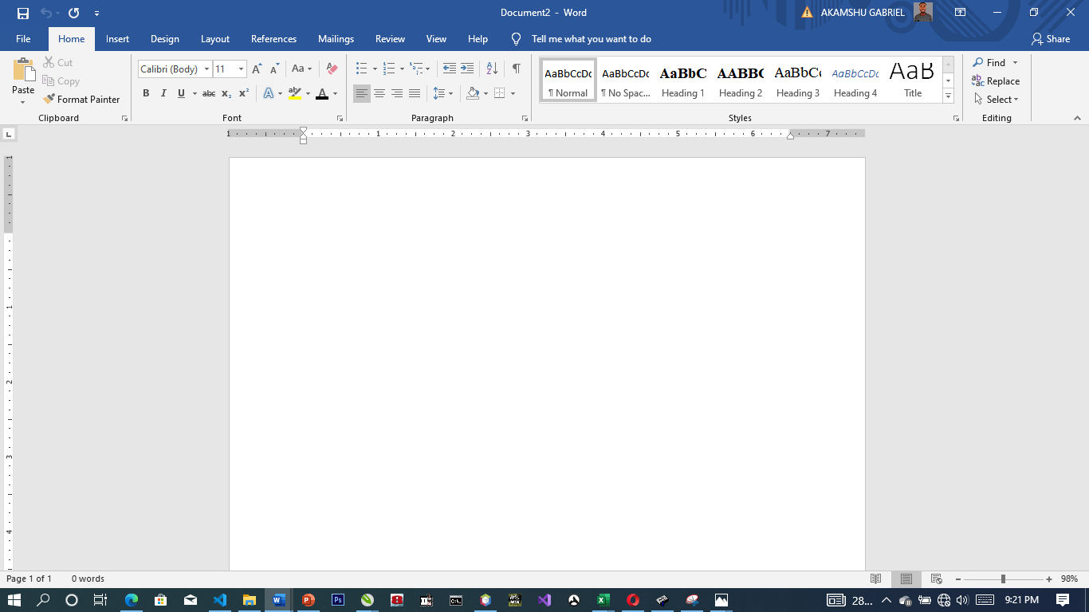

Figure 3.1: Microsoft word viewed screen.

1. The title bar: wherever you saved any work, the file name and reside on the title bar
2. The menu bar: menu bar is made up of (file, edit, view, insert, format, tools, table, and window help).
3. The standard tool bar: consist of spelling and grammar icon, help.
4. The formatting tools bar: contain **(Bold (B), *(I), Italic* underline (U).**
5. **The drawing tools bar:** consist of any thin like auto shape, square, circle, text, word art pie chart, and bar chart etc.
6. **The insertion point:** or cursor is a place where you can insert table, row column etc.
7. **The ruler:** rule is mean for adjusting the MS-word environment etc.

**3.3 COREL DRAW**

**CORELDRAW:** is a software application package used mostly for graphic system designed. It is written by CorelDraw system cooperation and runs on Microsoft windows. It is known to be one of the best design graphic software. It uses mean to carry out most task operation need to created design and pattern.

**3.3.1 ADVANTAGE OF CORELDRAW.**

* + - 1. is easy to create graphics and design.
      2. In the CorelDraw there is room for text entry and design.
      3. In CorelDraw these enhancement tool for measuring and object.
      4. It allowed us to manipulate graphics more than one.

**3.3.2 WAYS OF LODING CORELDRAW.**

There are two basic ways which is mentioned below:

1. Click on start on the task bar (i.e. windows 7)
2. Click on all program.
3. Select CorelDraw. OR
4. Double click the icon on the desktop environment.

**3.3.3 DIFFERENT VERSION OF CORELDRAW.**

There are many tools in CorelDraw and here are few of them listed below.

1. Version 8
2. Version 9
3. Version 10
4. Version 11
5. Version 12
6. Version 13
7. Version 14
8. Version 17…e.t.c

**3.3.4 CORELDRAW TOOLS.**

There are many tools in CorelDraw and here are few of them listed below.

1. Pick tool
2. Shape tool
3. Eraser tool
4. Knife tool
5. Zoo tool
6. Hand tool
7. Free hand tool
8. Rectangle tool
9. Polygon tool
10. Eclipse tool
11. Artistic media
12. Basic tool.

**3.3.5 HOW TO FIT TEXT TO PATH**

Fit text to path means making text to be in a circle or round from or any shape of your choice.

Below are steps of how to do it. Create the text and the shape style you want to use for your fit text path.

1. Highlight the destination path.
2. Select text
3. Go to text menu
4. Click on fit text to path command
5. Move your mouse pointer to hit destination path and click ok button.

**3.3.6 HOW POWERCLIP OBJECT**

An object created by placing object (contents objects) inside other (container objects).

**TO CREATE A POWERCLIP OBJCT**

1. Click pick tool
2. Click the object
3. Click Effect on the menu bar
4. Click PowerClip.
5. Click place inside container

**3.4 MICROSOFT POWERPOINT**

**3.4.1 WHAT IS MICROSOFT POWERPOINT**

Microsoft PowerPoint is one of the most popular technology that is being used by many of us in our day in day out to present our views in more attractive and precise way with numerous special effects. With a few clicks, user can add graphics, text, visuals, sounds and many more effects. In most of the Business meetings, PowerPoint presentation making the sessions more interesting for the listeners compared to old traditional way of representation.  Sometimes abbreviated as PP or PPT, PowerPoint is a presentation [program](https://www.computerhope.com/jargon/p/program.htm) developed by [Microsoft](https://www.computerhope.com/comp/msoft.htm) that creates a slide show of important information, charts, and images for a presentation. It is most often used for business and school presentations.

## 3.4.2 Powepoint Ribbon Tabs

The ribbon tabs group tools and features together based on their purpose. For example, to make your slides look better, look for options on the Design tab. The tools that you use to animate things on your slide would be on the Animations tab.

Here’s a look at what you’ll find in each of the PowerPoint ribbon tabs.

### 1. Home

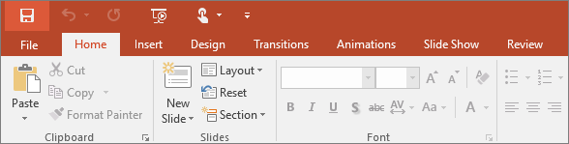

The Home tab holds the **Cut** and **Paste** features, **Font** and **Paragraph** options, and what you need to add and organize slides.

### 2. Insert

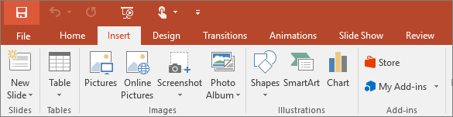

Click **Insert** to add something to a slide. This includes pictures, shapes, charts, links, text boxes, video and more.

### 3. Design

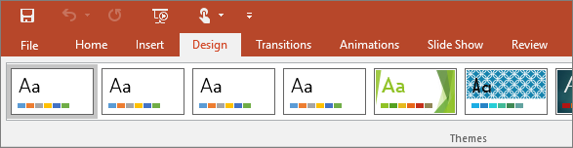

On the **Design** tab, you can add a theme or color scheme, or format the slide background.

### 4. Transitions

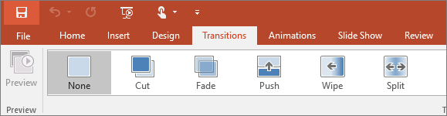

Set up how your slides change from one to the next on the **Transitions** tab. Find a gallery of the possible transitions in the **Transition to This Slide** group – click **More** More button at the side of the gallery to see all of them.

### 5. Animations

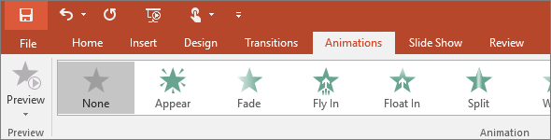

Use the **Animations** tab to choreograph the movement of things on your slides. Note that you can see many possible animations in the gallery in the Animation group, and see more of them by clicking **More** More button.

### 6. Slide show

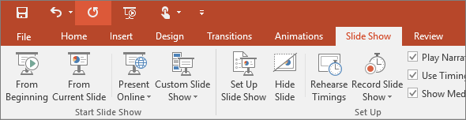

On the **Slide Show** tab, set up the way that you want to show your presentation to others.

### 7. Review

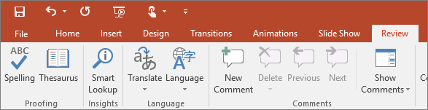

The **Review** tab lets you add comments, run spell-check, or compare one presentation with another (such as an earlier version).

### 8. View

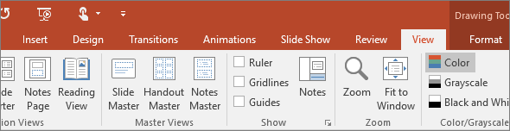

Views allow you to look at your presentation in different ways, depending on where you are in the creation or delivery process.

### 9. File

At one end of the ribbon is the **File** tab, which you use for the behind-the-scenes stuff you do with a file, such as opening, saving, sharing, exporting, printing and managing your presentation. Click the **File** tab to open a new view called the Backstage.

Click from the list on the side to do what you want to do; for example, click **Print** to find the options and settings for printing your presentation. Click Back Back to document to return to the presentation that you were working on.

### 10. Tools tab

When you click some parts of your slides, such as pictures, shapes, SmartArt or text boxes, you might see a colorful new tab appear.

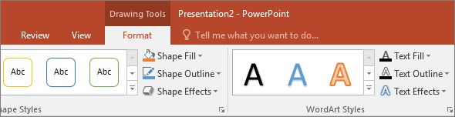

In the example above, the **Drawing Tools** tab appears when you click a shape or text box. When you click a picture, the **Picture Tools** tab appears. Other such tabs include SmartArt Tools, Chart Tools, Table Tools and Video Tools. These tabs disappear or change when you click something else in your presentation.

**HOW TO OPEN OR START POWERPOINT**

1. Click the Windows "Start" button, and then select “All Programs.”
2. Scroll through the list of folders that appear to find the folder labeled “Microsoft Office.”
3. Click that folder, and then click the “Microsoft PowerPoint” icon to open PowerPoint.

**How to start and stop a PowerPoint slide show**

After creating a set of slides or a presentation in [Microsoft PowerPoint](https://www.computerhope.com/jargon/p/powerpoi.htm), you can play the slides as a [slide show](https://www.computerhope.com/jargon/s/slidesho.htm), displaying them as [full screen](https://www.computerhope.com/jargon/f/fullscre.htm) on your computer. A PowerPoint slide show is an excellent visual aid when presenting important information and images to others on a web conference.

There are three ways to start a slide show in PowerPoint:

1. Open Microsoft PowerPoint, then open your presentation.
2. Click the Slide Show tab in the [Ribbon](https://www.computerhope.com/jargon/r/ribbon.htm).
3. To start the slide show from the first slide, click the From Beginning option in the Start Slide Show section.
4. To start the slide show from a slide other than the first, select that slide in your presentation, then click the From Current Slide option in the Start Slide Show section.

or

Open Microsoft PowerPoint, then open your presentation.

In the lower-left or lower-right area of the PowerPoint program window, click the Slide Show PowerPoint - Start slide show icon. The slide show starts from the currently-selected slide in your presentation.

or

1. Open Microsoft PowerPoint, then open your presentation.
2. To start the slide show from the first slide, press the [F5](https://www.computerhope.com/jargon/f/f5.htm) key.
3. To start the slide show from a slide other than the first, select that slide in your presentation, then press the [Shift](https://www.computerhope.com/jargon/s/shiftkey.htm)+F5 [key combination](https://www.computerhope.com/jargon/k/key-combination.htm).

**Stop a PowerPoint slide show**

To stop a slide show that is currently running in PowerPoint, press the [Esc](https://www.computerhope.com/jargon/e/esc.htm) key. Upon doing so, the slide show ends and the PowerPoint program window is displayed again.

**3.5 INTRODUCTION TO MS ACCESS**

Microsoft Access is a Database Management System (DBMS) from Microsoft that combines the relational Microsoft Jet Database Engine with a graphical user interface and software development tools. It is a member of the Microsoft Office suite of applications, included in the professional and higher editions.

1. Microsoft Access is just one part of Microsoft’s overall data management product strategy.
2. It stores data in its own format based on the Access Jet Database Engine.
3. Like relational databases, Microsoft Access also allows you to link related information easily. For example, customer and order data. However, Access 2013 also complements other database products because it has several powerful connectivity features.
4. It can also import or link directly to data stored in other applications and databases.

**HOW TO USE MS ACCESS**

Microsoft Access stores information which is called a database. To use MS Access, you will need to follow these four steps:

1. **Database Creation** - Create your Microsoft Access database and specify what kind of data you will be storing.
2. **Data Input** - After your database is created, the data of every business day can be entered into the Access database.
3. **Query** - This is a fancy term to basically describe the process of retrieving information from the database.
4. **Report** (optional) - Information from the database is organized in a nice presentation that can be printed in an Access Report.

**Creating a Database**

1. Start **Access**
2. Click on **Blank desktop database**

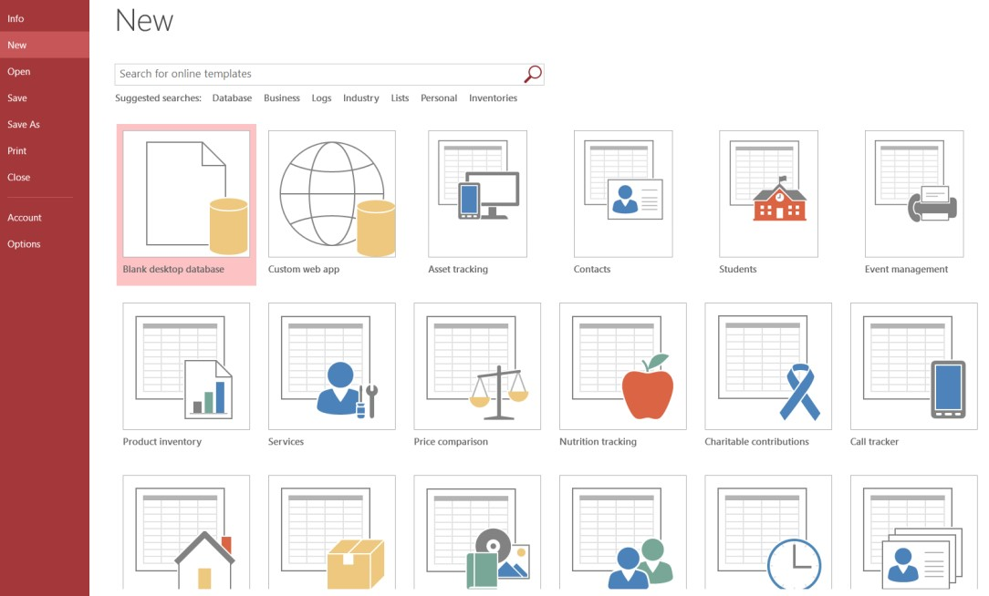

1. Under **File Name** type a name for the database
2. To change the location of where to store the database, click the folder icon and select a location
3. Click **Create**

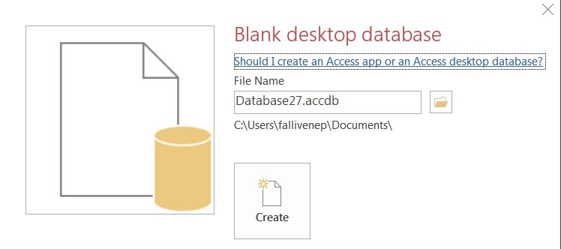

**To Save the Table:**

1. Click the **Save** icon on the toolbar
2. Enter a name for the table if you haven’t done so already
3. 3. Click **OK**

**Entering Data in a Table:**

1. In **Datasheet View**, start typing the data into the table by pressing the tab key to move to the next cell
2. When you have completed the record (row), press **Enter**
3. You can also click on the **New record** icon on the **Home** tab in the **Records** group

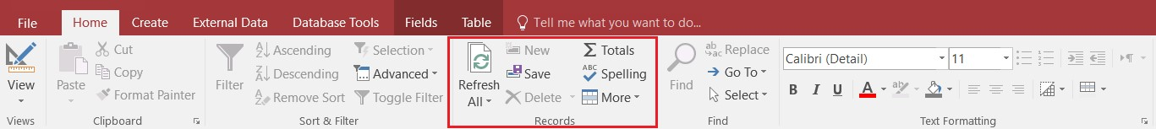

**Navigating in a Table:**

Use the arrows at the bottom of the table to navigate among records.



**Sorting Records in a Table:**

1. Position your cursor in the field that you wish to sort by clicking on any record in the table
2. Click either the **Sort Ascending** or **Sort Descending** icon on the **Home** tab in the **Sort & Filter** group

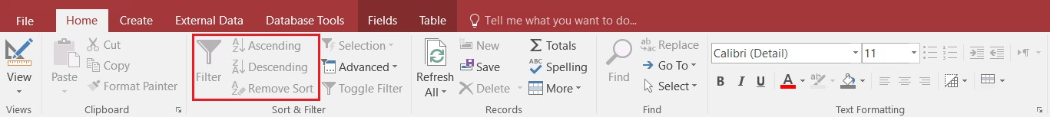

**Queries:**

You use queries to view, change, and analyze data in different ways. You can also use them as a source of records for forms and reports.

**To Create a Query:**

1. Click on the **Create** tab
2. Click on **Query Design** in the **Queries** group
3. Select the table that you would like to base your query on
4. Click **Add**
5. Repeat steps 3 and 4 until all tables are added
6. Close the Show Table window. The table(s) will now be displayed in the upper part of the **Query Design Screen** by boxes containing the tables’ fields.
7. **Double-click** on the field names in the field list window which you would like to include in the query

**Defining Criteria in the Query**

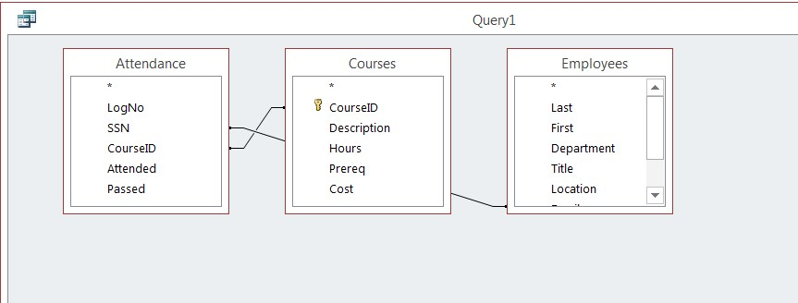

In order to control which records are displayed, you must define criteria in a query. The most common type of query is the **Select Records** query which will be discussed below.

**To Define Criteria for Your Query:**

1. Position your cursor in the criteria row in the field for which you wish to define the criteria for
2. **Type** the criteria. Example: To find all Excel courses:
3. Position your cursor in the criteria row of the **Course ID** field
4. **Type** Excel (Access adds the quote marks to the criteria automatically when you tab to the next column)

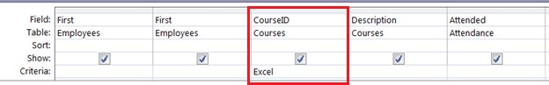

1. Click the **Run Query** button 

**To Save the Query:**

1. Click the **Save** icon
2. Enter a name for the query
3. Click **OK**

**MS ACCESS DATA TYPES**

|  |  |  |
| --- | --- | --- |
| **Type of Data** | **Description** | **Size** |
| **Short Text** | Text or combinations of text and numbers, including numbers that do not require calculating (e.g. phone numbers). | Up to 255 characters. |
| **Long Text** | Lengthy text or combinations of text and numbers. | Up to 63, 999 characters. |
| **Number** | Numeric data used in mathematical calculations. | 1, 2, 4, or 8 bytes (16 bytes if set to Replication ID). |
| **Date/Time** | Date and time values for the years 100 through 9999. | 8 bytes. |
| **Currency** | Currency values and numeric data used in mathematical calculations involving data with one to four decimal places. | 8 bytes. |
| **AutoNumber** | A unique sequential (incremented by 1) number or random number assigned by Microsoft Access whenever a new record is added to a table. | 4 bytes (16 bytes if set to Replication ID). |
| **Yes/No** | Yes and No values and fields that contain only one of two values (Yes/No, True/False, or On/Off). | 1 bit. |

**CREATE A TABLE IN DESIGN VIEW**

**To Create a Table in Design View:**

1. Click on the **Create** tab
2. Click on **Table**
3. Switch over to **Design View** on the **Home** tab
4. If prompted to save the table, enter a name and click on **OK**
5. Type the field names and select the appropriate data type for each field
6. Continue until all fields are added

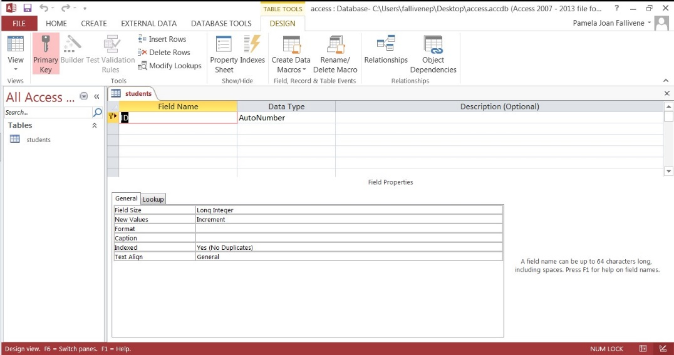

**CHAPTER FOUR**

**SUMMARY, CONCLUSION, PROBLEMS AND RECOMMENDATIONS**

# 4.1 SUMMARY

The relevance of the SIWES program cannot be over emphasized considering the fact that it has significantly reduced the gap between my theoretical and practical knowledge about computer hardware and software, installations, maintenance and networking. The processes of communication which include data and telecommunication the use of switch in the networking and what networking is all about.

The program is indeed a commendable one in that it affords students ample opportunities of being exposed to good working relationship with colleagues and the field experience with customers. This little exposure has widened my knowledge about my course of study, not only that it has automatically changed my views about lift in general. The firm at large has taught me how to be independent of my own how to be conscious of my health and safety at its peak relating to the environment where I carried out my SIWES program. It was indeed a highly rewarding experience to be with Community Resources Center, Jada, Gombi, Adamawa State.

**4.2 CONCLUSION**

In conclusion, I thank ITF in general for their effort towards the Student Industrial Training Scheme. The contribution that the industrial training offered to student will not be over emphasized. It has exposed me seriously to a certain depth and length of practical capability on Computer Knowledge and practical Know how.

It has also acquainted me with the working condition, which I am expected to encounter in the near future. I will say that SIWES has a greater advantage on me, it has greatly exposed me to the practical application of all that I have been through in the school, SIWES is an experience that all student must pass through this is because it gives a full practical knowledge of what has been through in classroom.

Finally, I have a strong believe that this comprehensive based on the experience, I acquired during the industrial training scheme will convince every user training is not difficult.

I therefore strong conclude that the continuous existence of SIWES programme as it is very necessary since it plays a dominant role in the development of student of Computer Science in the acquisition of practical experience.

# 4.3 PROBLEMS OBSERVED DURING MY PROGRAM

1. The time frame set for the program is too short as some of the aspects of the program where not completed.
2. Lack of Financial support from the company to aid transportation to and from training.
3. Attentions are not given to the IT students by the workers it is learn if you want to learn or ask if you want to know.
4. Cost of Training: The Student has to be registered as a student of a particular organization in order to carry out the program.

**4.4 RECOMMENDATIONS**

Below are the recommendations that should be given serious consideration so as alleviate the suffering of students undergoing SIWES.

Firstly, the Federal Government of Nigerian should make a positive effort in reducing the overall cost of production so that companies should be producing to fill capacity and accommodate SIWES populaces. Also, certain monthly allowance may be given to the student by company accepted then (student to ease transportation problem).

Secondly, the Industrial Training Fund (ITF), should try and increase the money paid at the end of SIWES to the student so as to justify the Cost of Living we experienced.

Finally, the ITF official should please continue visiting the students, to ensure that what they are learning is in line with the ITF requirement.

**REFERENCES**

Edward, B. M.D (2003). The Effect of SIWES on a student, Federal Ministry of Works, Lagos. Nigeria.

Lowenthal, R. (2009).[*Improving the Design of PowerPoint Presentations*](http://www.ucdenver.edu/academics/CUOnline/FacultySupport/Handbook/Documents/Chapter_12.pdf). University of Colorado Denver.